DDL Commands in MySQL – Explanation with Examples
- CREATE A DATABASE
CREATE DATABASE CollegeDB;
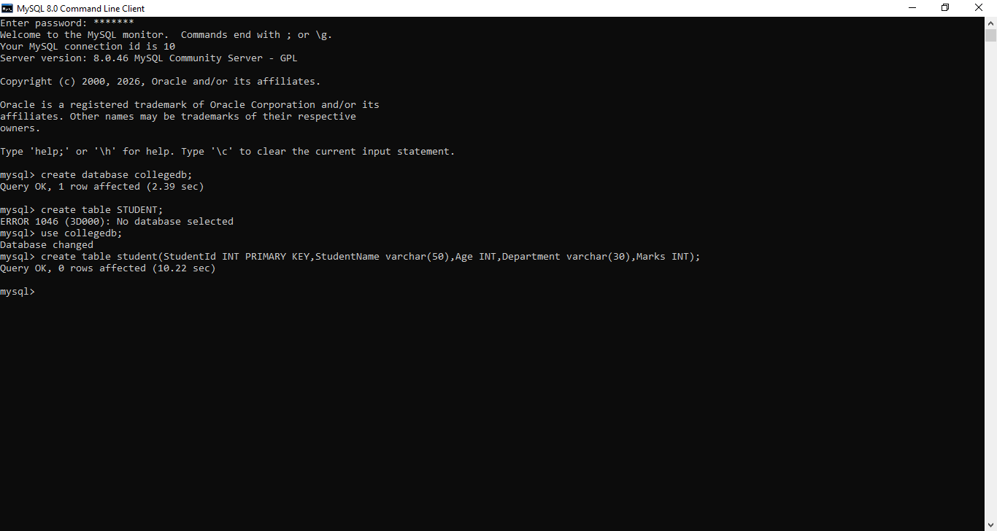

USE A DATABASE
USE CollegeDB;

CREATE A TABLE
CREATE TABLE Students ( StudentID INT PRIMARY KEY,
StudentName VARCHAR(50), Age INT,
Department VARCHAR(30), Marks INT
);

INSERT INTO Students VALUES (101, 'Arun', 20, 'CSE', 85),
(102, 'Bala', 21, 'IT', 90),
(103, 'Charan', 19, 'ECE', 78);

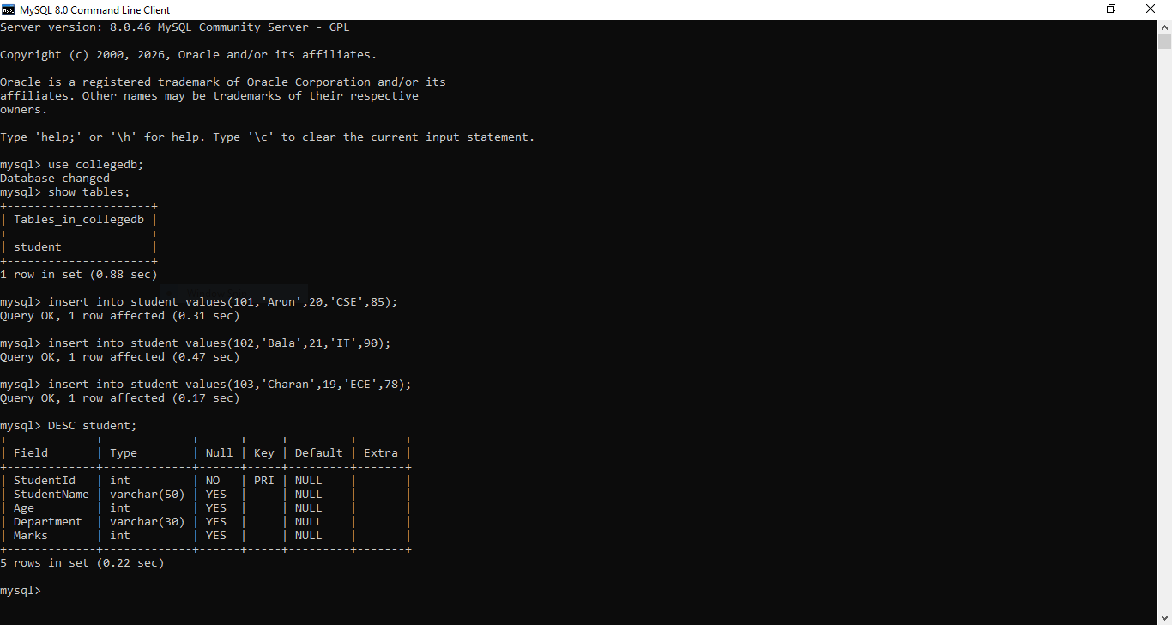

DESCRIBE A TABLE
DESC Students;

ADD A NEW COLUMN
ALTER TABLE Students ADD Email VARCHAR(100);

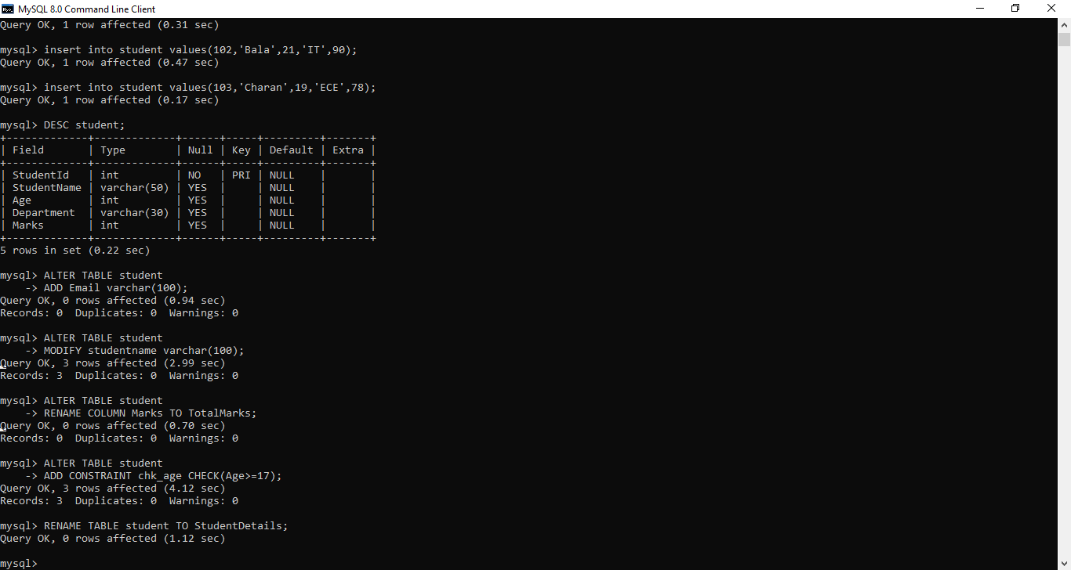

MODIFY A COLUMN DATATYPE
ALTER TABLE Students
MODIFY StudentName VARCHAR(100)

RENAME A COLUMN
ALTER TABLE Students
RENAME COLUMN Marks TO TotalMarks;

ADD A CONSTRAINT
ALTER TABLE Students
ADD CONSTRAINT chk_age CHECK (Age >= 17);

RENAME A TABLE
RENAME TABLE Students TO StudentDetails;

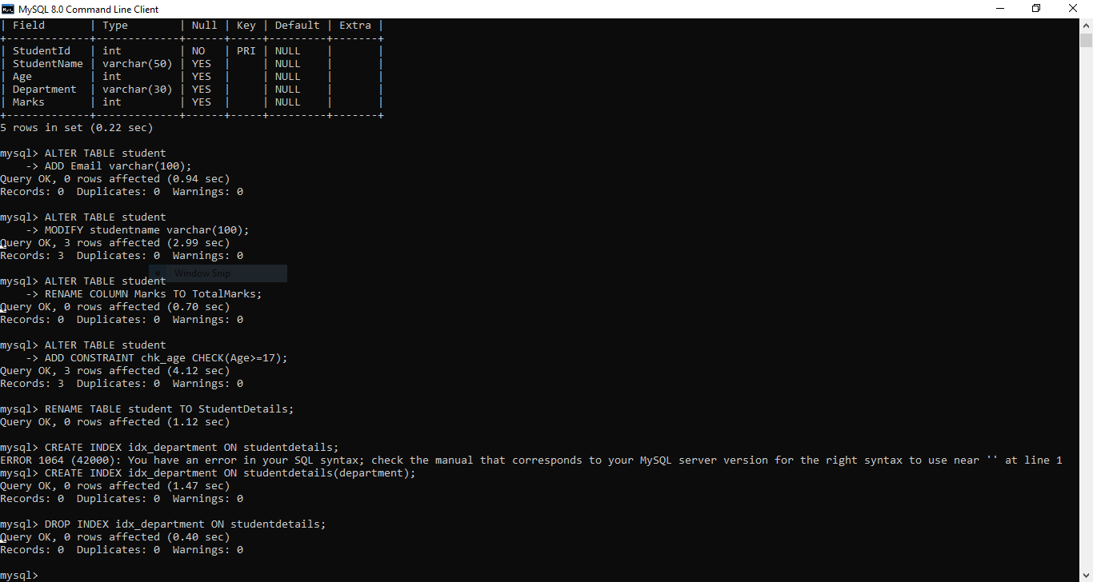

CREATE INDEX
CREATE INDEX idx_department ON StudentDetails(Department);

DROP INDEX
DROP INDEX idx_department ON StudentDetails;

CREATE VIEW
CREATE VIEW CSEStudents AS
SELECT StudentID, StudentName, Age FROM StudentDetails
WHERE Department = 'CSE';
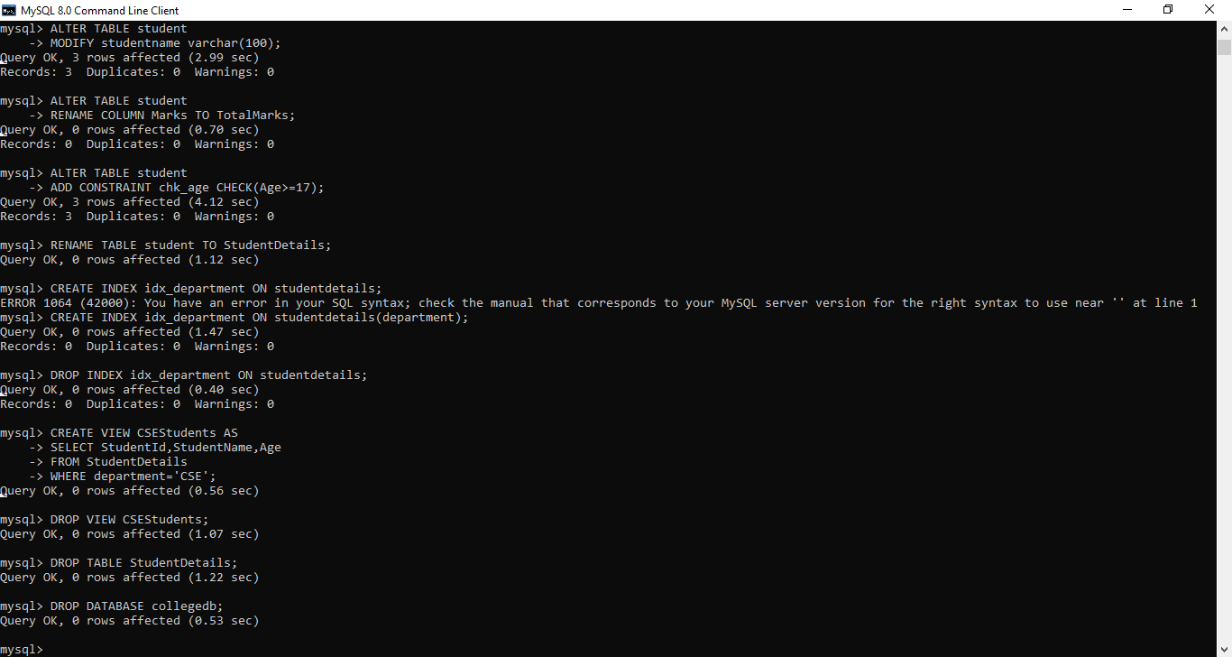

DROP VIEW
DROP VIEW CSEStudents;

DELETE A TABLE
DROP TABLE StudentDetails;

DELETE A DATABASE
DROP DATABASE CollegeDB;

